GCP Fundamentals: Getting Started with Compute Engine

25 minutesFree

Rate Lab

**Overview**

In this lab, you will create virtual machines (VMs) and connect to them. You will also create connections between the instances.

**Objectives**

In this lab, you will learn how to perform the following tasks:

* Create a Compute Engine virtual machine using the Google Cloud Platform (GCP) Console.
* Create a Compute Engine virtual machine using the gcloud command-line interface.
* Connect between the two instances.

**Task 1: Sign in to the Google Cloud Platform (GCP) Console**

**Before you click the Start Lab button**

Read these instructions. Labs are timed and you cannot pause them. The timer, which starts when you click Start Lab, shows how long Cloud resources will be made available to you.

This Qwiklabs hands-on lab lets you do the lab activities yourself in a real cloud environment, not in a simulation or demo environment. It does so by giving you new, temporary credentials that you use to sign in and access the Google Cloud Platform for the duration of the lab.

**What you need**

To complete this lab, you need:

* Access to a standard internet browser (Chrome browser recommended).
* Time to complete the lab.

***Note:*** If you already have your own personal GCP account or project, do not use it for this lab.

**Task 2: Create a virtual machine using the GCP Console**

1. In the **Navigation menu** (), click **Compute Engine** > **VM instances**.
2. Click **Create**.
3. On the **Create an Instance** page, for **Name**, type my-vm-1
4. For **Region** and **Zone**, select the region and zone assigned by Qwiklabs.
5. For **Machine type**, accept the default.
6. For **Boot disk**, if the **Image** shown is not **Debian GNU/Linux 9 (stretch)**, click **Change** and select **Debian GNU/Linux 9 (stretch)**.
7. Leave the defaults for **Identity and API access** unmodified.
8. For Firewall, click **Allow HTTP traffic**.
9. Leave all other defaults unmodified.
10. To create and launch the VM, click **Create**.

**Note**: The VM can take about two minutes to launch and be fully available for use.

Click *Check my progress* to verify the objective.

Create a virtual machine using the GCP Console

Check my progress

**Task 3: Create a virtual machine using the gcloud command line**

1. In GCP console, on the top right toolbar, click the Open Cloud Shell button.

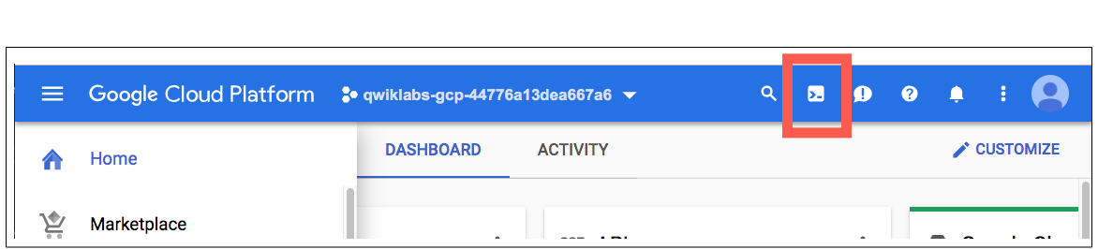

1. Click **Continue**. 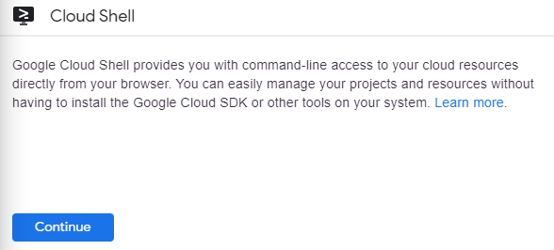
2. To display a list of all the zones in the region to which Qwiklabs assigned you, enter this partial command gcloud compute zones list | grep followed by the region that Qwiklabs or your instructor assigned you to.

Your completed command will look like this:

gcloud compute zones list | grep us-central1

1. Choose a zone from that list other than the zone to which Qwiklabs assigned you. For example, if Qwiklabs assigned you to region us-central1 and zone us-central1-a you might choose zone us-central1-b.
2. To set your default zone to the one you just chose, enter this partial command gcloud config set compute/zone followed by the zone you chose.

Your completed command will look like this:

gcloud config set compute/zone us-central1-b

1. To create a VM instance called **my-vm-2** in that zone, execute this command:
2. gcloud compute instances create "my-vm-2" \
3. --machine-type "n1-standard-1" \
4. --image-project "debian-cloud" \
5. --image "debian-9-stretch-v20190213" \
6. --subnet "default"

**Note**: The VM can take about two minutes to launch and be fully available for use.

1. To close the Cloud Shell, execute the following command:
2. exit

Click *Check my progress* to verify the objective.

Create a virtual machine using the gcloud command line

Check my progress

**Task 4: Connect between VM instances**

1. In the **Navigation menu** (), click **Compute Engine > VM instances**.

You will see the two VM instances you created, each in a different zone.

Notice that the Internal IP addresses of these two instances share the first three bytes in common. They reside on the same subnet in their Google Cloud VPC even though they are in different zones.

1. To open a command prompt on the **my-vm-2** instance, click **SSH** in its row in the **VM instances** list.
2. Use the ping command to confirm that **my-vm-2** can reach **my-vm-1** over the network:
3. ping my-vm-1

Notice that the output of the ping command reveals that the complete hostname of **my-vm-1** is **my-vm-1.c.PROJECT_ID.internal**, where PROJECT_ID is the name of your Google Cloud Platform project. GCP automatically supplies Domain Name Service (DNS) resolution for the internal IP addresses of VM instances.

1. Press **Ctrl+C** to abort the ping command.
2. Use the **ssh** command to open a command prompt on **my-vm-1**:
3. ssh my-vm-1

If you are prompted about whether you want to continue connecting to a host with unknown authenticity, enter **yes** to confirm that you do.

1. At the command prompt on **my-vm-1**, install the Nginx web server:
2. sudo apt-get install nginx-light -y
3. Use the **nano** text editor to add a custom message to the home page of the web server:
4. sudo nano /var/www/html/index.nginx-debian.html
5. Use the arrow keys to move the cursor to the line just below the h1 header. Add text like this, and replace YOUR_NAME with your name:
6. Hi from YOUR_NAME
7. Press **Ctrl+O** and then press **Enter** to save your edited file, and then press **Ctrl+X** to exit the nano text editor.
8. Confirm that the web server is serving your new page. At the command prompt on **my-vm-1**, execute this command:
9. curl http://localhost/

The response will be the HTML source of the web server's home page, including your line of custom text.

1. To exit the command prompt on **my-vm-1**, execute this command:
2. exit

You will return to the command prompt on **my-vm-2**

1. To confirm that **my-vm-2** can reach the web server on **my-vm-1**, at the command prompt on **my-vm-2**, execute this command:
2. curl http://my-vm-1/

The response will again be the HTML source of the web server's home page, including your line of custom text.

1. In the **Navigation menu** (), click **Compute Engine > VM instances**.
2. Copy the External IP address for **my-vm-1** and paste it into the address bar of a new browser tab. You will see your web server's home page, including your custom text.

If you forgot to click **Allow HTTP traffic** when you created the **my-vm-1** VM instance, your attempt to reach your web server's home page will fail. You can add a [firewall rule](https://cloud.google.com/vpc/docs/firewalls) to allow inbound traffic to your instances, although this topic is out of scope for this course.

**Congratulations!**

In this lab, you created virtual machine (VM) instances in two different zones and connected to them using ping, ssh, and HTTP.

**End your lab**

When you have completed your lab, click **End Lab**. Qwiklabs removes the resources you’ve used and cleans the account for you.

You will be given an opportunity to rate the lab experience. Select the applicable number of stars, type a comment, and then click **Submit**.

The number of stars indicates the following:

* 1 star = Very dissatisfied
* 2 stars = Dissatisfied
* 3 stars = Neutral
* 4 stars = Satisfied
* 5 stars = Very satisfied

You can close the dialog box if you don't want to provide feedback.

For feedback, suggestions, or corrections, please use the **Support** tab.

Copyright 2019 Google LLC All rights reserved. Google and the Google logo are trademarks of Google LLC. All other company and product names may be trademarks of the respective companies with which they are associated.

**More Resources**

Read the [Google Cloud Platform documentation on Google Compute Engine](https://cloud.google.com/compute/docs/).

Read about [Google Cloud Platform Virtual Private Cloud (VPC)](https://cloud.google.com/compute/docs/vpc/).